Arduino Uno

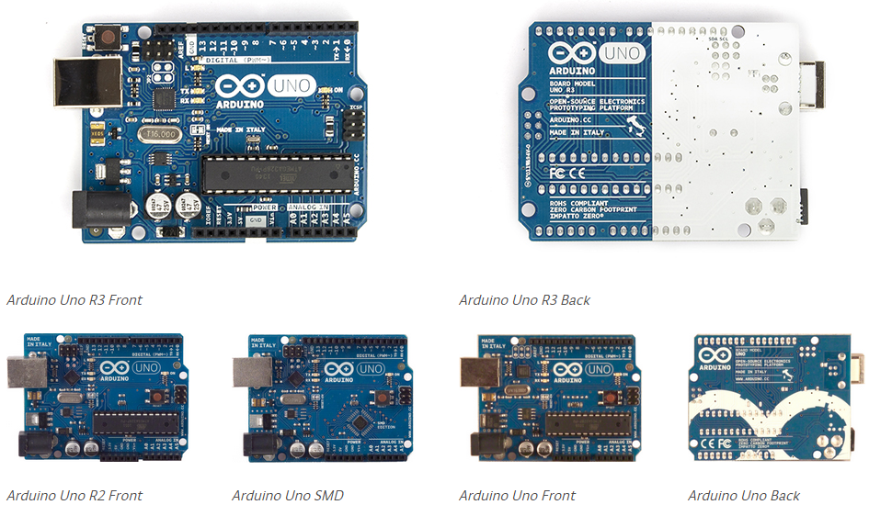

The Arduino Uno is a microcontroller board based on the ATmega328. It contains everything needed to support the microcontroller; simply connect it to a computer with a USB cable or power it with a AC-to-DC adapter or battery to get started.

### Summary

|  |  |
| --- | --- |
| **Microcontroller** | **ATmega328** |
| **Operating Voltage** | **5V** |
| **Input Voltage (recommended)** | **7-12V** |
| **Input Voltage (limits)** | **6-20V** |
| **Digital I/O Pins** | **14 (of which 6 provide PWM output)** |
| **Analog Input Pins** | **6** |
| **DC Current per I/O Pin** | **40 mA** |
| **DC Current for 3.3V Pin** | **50 mA** |
| **Flash Memory** | **32 KB (ATmega328) of which 0.5 KB used by bootloader** |
| **SRAM** | **2 KB (ATmega328)** |
| **EEPROM** | **1 KB (ATmega328)** |
| **Clock Speed** | **16 MHz** |
| **Length** | **68.6 mm** |
| **Width** | **53.4 mm** |
| **Weight** | **25 g** |